**Power & Structural System Demo Documentation**

**Power System Overview**

DC-DC Boost Converter

Micro-controller Load

H-Bridge

Artificial Muscle Load

Battery

Power Requirements

Microcontroller: 20mA x 10 I/O pins = 0.2Ah @ 7-12V

Artificial Muscle: 0.65-0.7Ah @ 12V

Total: ~0.9 – 1Ah @ 12V

**Battery**

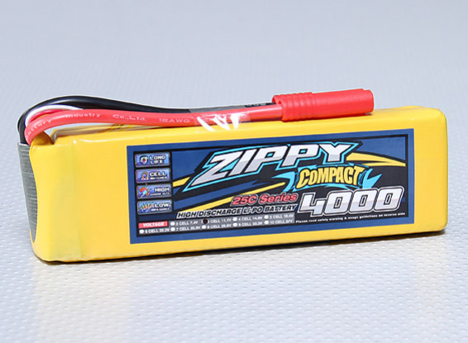1st Iteration:

3-cell (11.1V) 4000mAh LiPo

Safer than Li-Ion (lower chance to leak)

Stores less power than Li-Ion (ok because relatively less power requirement)

Current:

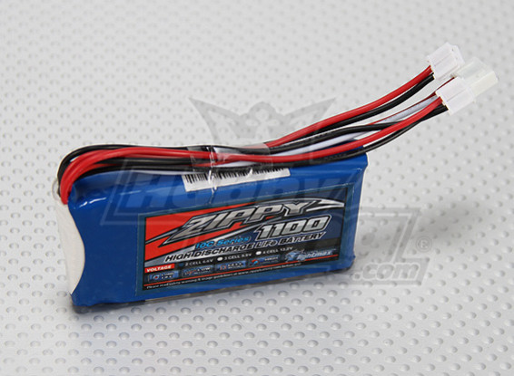2-cell (6.6V) 1100mAh LiFePo4

During converter design found boost converter to be easier to design than a buck-boost converter

Safer than LiPo (no combustion from self-heating – 60 degrees Celsius)

Smaller model but less power (still falls within requirements)

Cheap - $5 battery, ok to replace

**DC-DC Boost Converter**

IC: TPS61088 10A Fully-Integrated Synchronous Boost Converter

Input Voltage: 2.7-12V

Output Voltage: 4.5-12.6V

Output Current: 2A

Pulse-Frequency Modulation (light load) to use Vin to Vout ratio to predict off time switching cycle.

Design

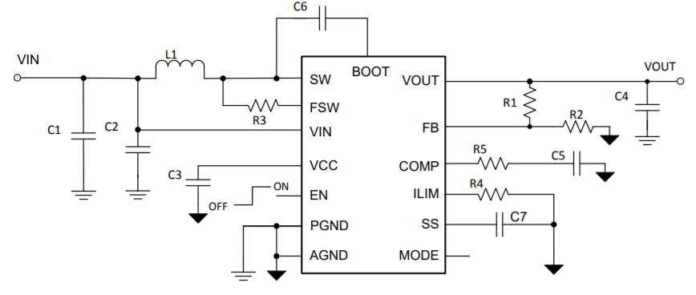

Where:

|  |  |  |  |
| --- | --- | --- | --- |
| C1 = | 22 uF | R1 = | 825 kΩ |
| C2 = | 100 nF | R2 = | 92 kΩ |
| C3 = | 1 uF | R3 = | 261 kΩ |
| C4 = | 22 uF | R4 = | 137 kΩ |
| C5 = | 560 pF | R5 = | 36.5 kΩ |
| C6 = | 100 nF | L1 = | 1.5 uH |
| C7 = | 8.2 nF |  |  |

Setting Switching Frequency Minimum 595.681 kHz (given)

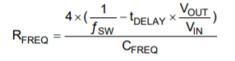 RFREQ = R3

Switching frequency will change according to Vout and Vin ratio, affecting duty cycle.

Setting Output Voltage using Voltage Divider

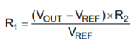

VREF = 1.212 V (given), R2 = 92 kΩ (given)

Inductor Selection

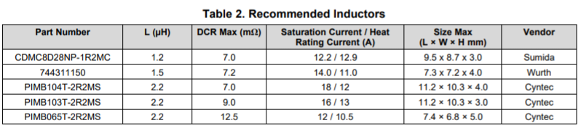

Simulation

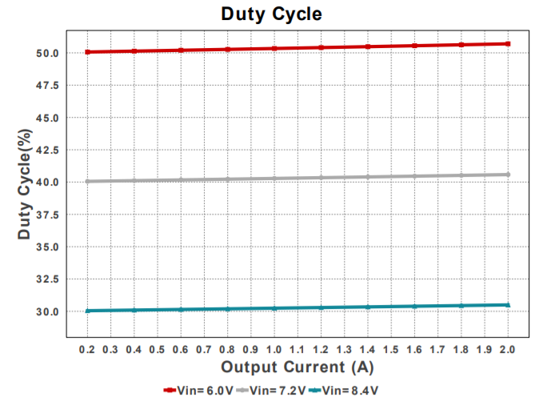

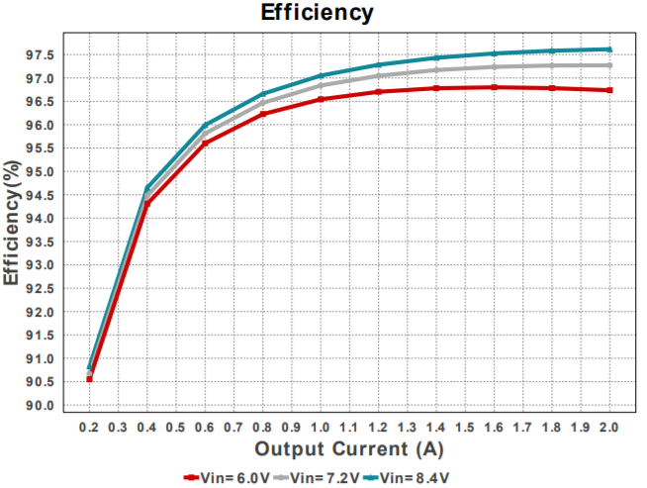

PCB Design

Layout Example

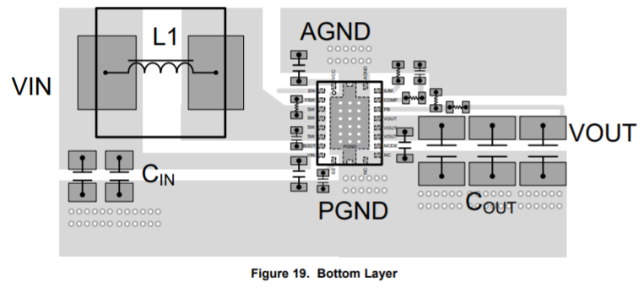

Eagle Multilayer Cam Files

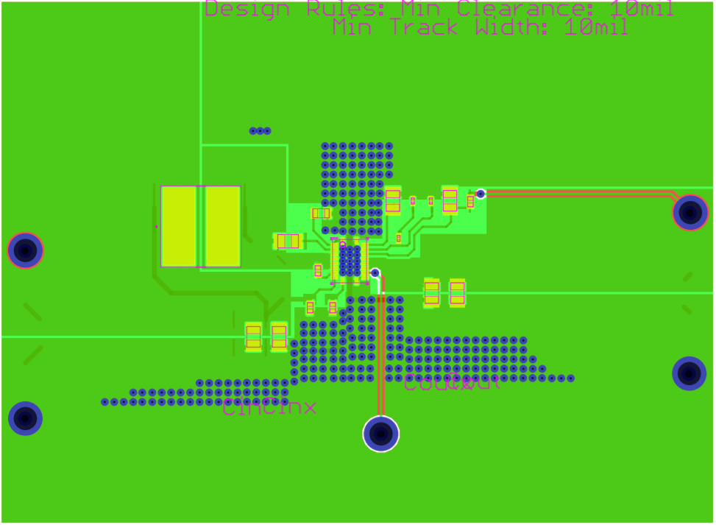

Design aid given by TPS61088 Datasheet & TI WEBENCH Power Designer for reference.

**H-Bridge**

IC: L293N Quadruple Half-H Drivers

Operating Conditions:

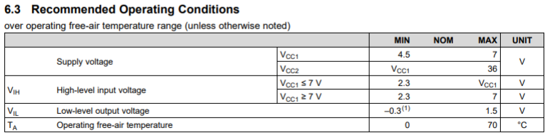 

Design

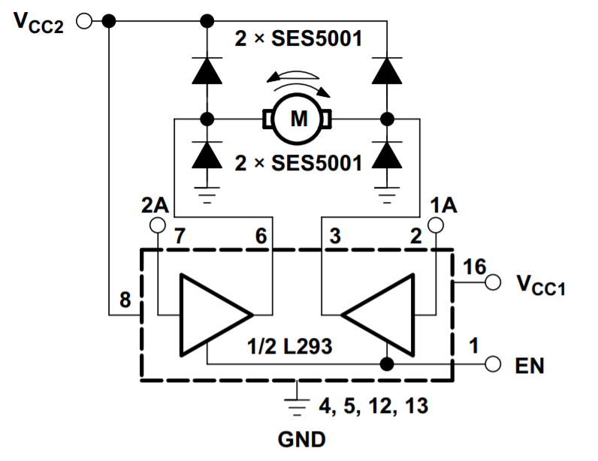

Using 1A Rectifier Diodes

Truth Table

|  |  |  |  |
| --- | --- | --- | --- |
| EN (Pin 1) | 1A (Pin 2) | 2A (Pin 7) | Function |
| 1 | 0 | 1 | Positive Current |
| 1 | 1 | 0 | Negative Current |
| 1 | 0 | 0 | No Current |

**Structural System**

1st Iteration:

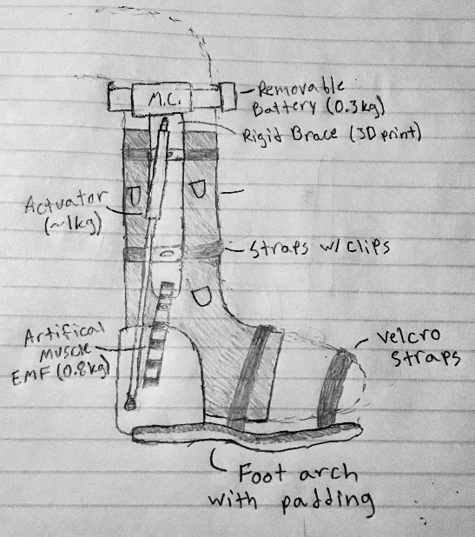

Features: Rigid brace for physical support, Foot arch for natural arch during rehabilitation, Velcro straps and straps with clips for “one size fits all” adjustability, Soft support to hold EMG sensors in place.

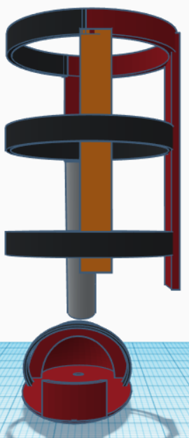

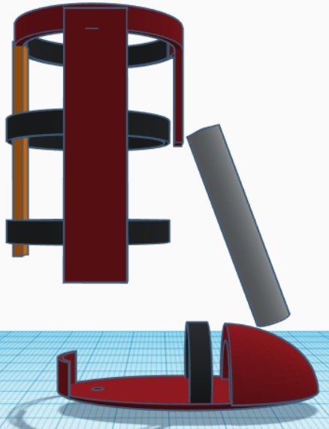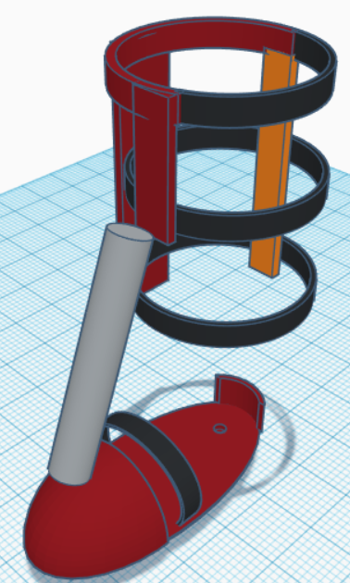Current:

Back View

Side View

Angle View

Legend:

Maroon – Rigid Material (longest piece will hold power system, sensor system, and microcontroller)

Orange – Soft Material (to be used as support for back of calf in conjuction with straps)

Black – Straps with clips

Gray – Artificial Muscle

Will still use a soft support to hold EMG sensors in place, may require a material that dissipates EM waves.

Dimensions based on 18” lower leg/calf length and foot size 10 ½” x 3 ½”.